ScreenShot 1:

If user has houses then His User Management page looks like this.

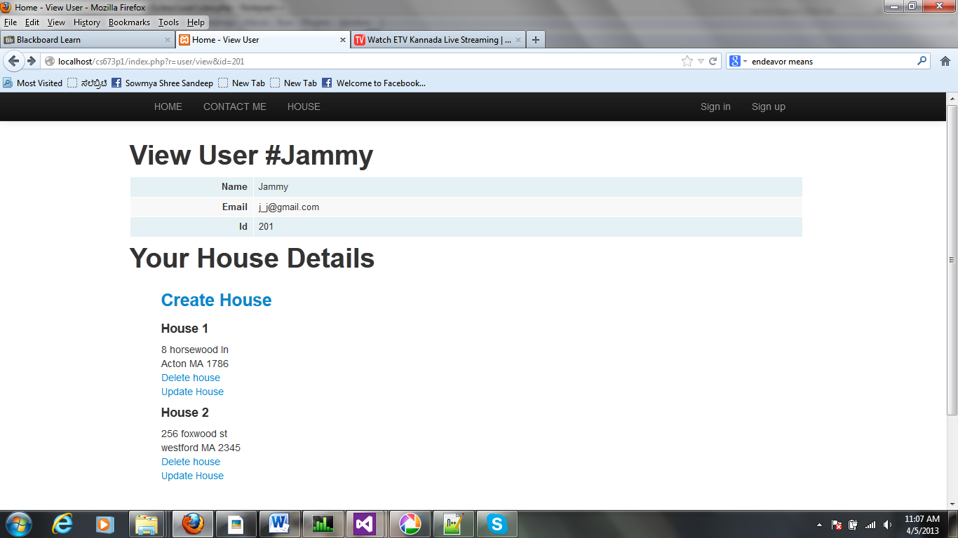

Screen Shot 2

Is User has no house it shows the following:

